**PROJECT PROPOSAL**

**ORGANIZATIONAL CULTURE AND JOB SATISFACTION OF EMPLOYEES WORKING IN CALL CENTRE**

**SUBMITTED BY**

**NAME: …………………………….**

**ENROLLMENT NO.: …………………………**

**PROGRAM: ………………………..**

**UNDER THE SUPERVISION OF**

**……………………………**



In contemporary western countries, the rapid development of science, medicine and

technology during the last century has led to enormous social, cultural and economical changes. The

fields of industry and investment have risen dramatically and the worldwide markethas become very

demanding and competitive. Therefore, a certain type of culture has arisen among employees,

indicating the type of the institutions’ internal organization and external strategies. However, the

recent worldwide financial crisis has led to unexpected fluctuation and disturbed the balance of global

market. As a result, the employees’ salaries have decreased, working hours have been extended and

working force has weakened.

Such upheavals have made employees more vulnerable to anxiety, disappointment and

aggressive behavior. In particular, employees have grown negative attitudes towards their working

conditions, superiors and colleagues, they tend to feel more stressed and less committed to their job,

have an urge to quit and experience high levels of disappointment and pessimism

In contemporary western countries, the rapid development of science, medicine and

technology during the last century has led to enormous social, cultural and economical changes. The

fields of industry and investment have risen dramatically and the worldwide markethas become very

demanding and competitive. Therefore, a certain type of culture has arisen among employees,

indicating the type of the institutions’ internal organization and external strategies. However, the

recent worldwide financial crisis has led to unexpected fluctuation and disturbed the balance of global

market. As a result, the employees’ salaries have decreased, working hours have been extended and

working force has weakened.

Such upheavals have made employees more vulnerable to anxiety, disappointment and

aggressive behavior. In particular, employees have grown negative attitudes towards their working

conditions, superiors and colleagues, they tend to feel more stressed and less committed to their job,

have an urge to quit and experience high levels of disappointment and pessimism

In contemporary western countries, the rapid development of science, medicine and

technology during the last century has led to enormous social, cultural and economical changes. The

fields of industry and investment have risen dramatically and the worldwide markethas become very

demanding and competitive. Therefore, a certain type of culture has arisen among employees,

indicating the type of the institutions’ internal organization and external strategies. However, the

recent worldwide financial crisis has led to unexpected fluctuation and disturbed the balance of global

market. As a result, the employees’ salaries have decreased, working hours have been extended and

working force has weakened.

Such upheavals have made employees more vulnerable to anxiety, disappointment and

aggressive behavior. In particular, employees have grown negative attitudes towards their working

conditions, superiors and colleagues, they tend to feel more stressed and less committed to their job,

have an urge to quit and experience high levels of disappointment and pessimism

In contemporary western countries, the rapid development of science, medicine and

technology during the last century has led to enormous social, cultural and economical changes. The

fields of industry and investment have risen dramatically and the worldwide markethas become very

demanding and competitive. Therefore, a certain type of culture has arisen among employees,

indicating the type of the institutions’ internal organization and external strategies. However, the

recent worldwide financial crisis has led to unexpected fluctuation and disturbed the balance of global

market. As a result, the employees’ salaries have decreased, working hours have been extended and

working force has weakened.

**INTRODUCTION**

An organization's shared perspective, shared knowledge, and intangible force are all parts of its organizational culture. The company stands out from the others thanks to this unique quality. The culture of a large for-profit company, for example, is very different from that of a hospital, which is different from that of a university.

Total job satisfaction is the culmination of a person's feelings about their position. However, if job satisfaction is linked to higher output, more organizational effectiveness, employee loyalty, and lower absenteeism and earnings, then employees who are unhappy at work may become dissatisfied with their jobs, which may increase costs, lower profits, and ultimately lead to dissatisfied customers. Pay has been identified as the most significant factor influencing work happiness despite years of efforts to identify and unearth other factors. However, other factors are also regarded as important, such as employee loyalty, job recognition, and promotions.

Job satisfaction and organizational culture

Work satisfaction refers to a person's overall perspective on their job. others who are highly satisfied with their jobs tend to have a positive attitude toward their profession, whereas others who are not as satisfied with their jobs tend to have a negative attitude toward their employment. A good work environment, a fair wage, additional benefits, tough tasks, supportive coworkers, strong leadership, and a capable manager who meets every employee's goals all have an impact on job satisfaction. Empirical research has been conducted on the effects of corporate culture on professional satisfaction, demonstrating the interdependencies among the variables. An organization's culture is strong if there is a stronger correlation between work satisfaction and organizational culture. An organization's culture is weak if there is a low correlation between work satisfaction and organizational culture.

Numerous studies have found a connection between employee consensus and culture. However, this correlation depends on individual differences. In conclusion, it can be claimed that when employee expectations and organizational culture mesh, satisfaction levels are high. An organizational culture that prioritizes individual effort, does not place a high priority on monitoring and control, and values people based only on their accomplishments, for example, will require greater success and emphasize the importance of autonomy for those in positions of authority. In his work, this fact is tremendously fulfilling. As such, enjoyment is contingent upon your perceptions of corporate culture.

**REVIEW OF LITERATURE**

Sattar and Ali (2016) measures the factors affecting the employee satisfaction by discussing variables such as promotion, work environment, leadership and job satisfaction and observe its impact on workers of the banking industry at Bahawalpur district. It was determined that all the variables promotions, work environment, leadership behaviour and job satisfaction have significant relationship with employees job satisfaction.

Salem et al., (2013), concludes that most people or employees agreed that personality type suits the work they do, and have the opportunity to do what they do best and they are also optimistic about their personal and professional life and further demonstrates that fair policy of recruitment and selection leads to employee satisfaction at work.

Presence of higher degree of occupational stress adversely affected the level of job satisfaction and if employees are allottted low burden of tasks, targets and operational activities to perform for their customers than they‘ll become more calm, happy and satisfied with their jobs instead of having hectic workload, burden and tension created by the line managers as well as customers (Khan, Ramzan & Butt, 2013).

Singh, T., & Sundaray, B. K. (2012), in their study examined job satisfaction level of executives in private and public sector business organizations. The sample for the study consisted of 75 executives from both these sectors. It was found that job satisfaction is not a single factor but consists of nine aspects. The private sector executives have the highest level of job satisfaction as compared to public sector executives on the basis of nature of work they are engaged in, followed by communication, supervision, coworkers, promotion, contingent rewards, pay, fringe benefits and operating condition dimensions. Further it also came to know that the relationship with co-workers is an important aspect of job satisfaction and not the pay structure.

Pepe, M. (2010), in his study investigated the relationship between extrinsic motivational factors such as perceived supervisor support and job satisfaction, organizational commitment and the intent to leave with a sample of 46 managers and clerical support staff in a supermarket retailer. It was found that job satisfaction is important in measuring the intent to turnover and is constantly found to be negatively related to intent to leave. Job dissatisfaction stimulates thoughts of leaving, which leads the individual to evaluate the expected utility of search, intention to search, the search itself, evaluation of alternatives, intention to quit, and finally the withdrawal decision and behaviour. It was found that job satisfaction is an attitudinal cause of commitment and is therefore, important to the study of organizational commitment and turnover.

Hunjra, A. I., Chani, M. I., Aslam, S., Azam, M., & Rehman, K. U. (2010), in their study measured the effect of human resource management practices like autonomy, leadership behaviour and team work on job satisfaction with a sample of 295 employees working in different banks of Rawalpindi, Islamabad and Lahore. The finding was found that employees weigh more to leadership behaviour and team work environment, than autonomy, to enhance their job satisfaction. So the management should focus on leadership behaviour to their employees and should provide them with a good team work environment which will enhance their level of job satisfaction. This will also reduce absenteeism and turnover. The empirical analysis of this study suggests that male employees should be prioritized while formulating human resource strategies as compared to female employees. The human resource strategies should not be devised on gender discrimination basis but include both categories that is male and female.

Emmema, A.A., Ajjan, N., & Karthikeyan, C. (2010), in their study examined the factors responsible for employee engagement. It came to know from the result that the success of an organization depends on employee engagement which is a main key for improving both productivity and profitability of an organization with a sample of 100 employees of MGM Corporate, Chennai. Engaged employees are more committed and satisfied with the job which paves way for many other factors such as loyalty, employee retention etc. The key drivers responsible for employee engagement were found to be job satisfaction, organizational behavior, motivation and employee welfare. Besides that better working environment, improved facilities like cafeteria, recreation room, and indoor games, followed by compensation and benefits are the major needs of the employees.

Vanar, V. M. (2012), in his study investigated the relationship between employees’ satisfaction and industrial relations in selected industrial units of Ahmedabad and Anand districts. It was found that inadequate welfare measures and absence of motivation are the root problems for indiscipline, and so employers should urgently frame such effective employee’s welfare policy which motivates them to work efficiently without creating troubles in the organization. It was also found that job satisfaction is important because the committed and engaged employees create satisfied work group which leads to pleasant industrial relations. It also came to know that employers should take suggestions from employees while making any policy which affects the industrial relations of the organization.

Gyanchandani, R., Badrinarayan, S. R., & Sharma, S. (2011), in their study investigated the factors which leads to job stress and their impact on job satisfaction with a sample size of 50 respondents in the service sector of Pune region. It was found that employees who are highly motivated are satisfied and are ready to work more for the organization. It came to know that employees found absence of some factors such as effective support system, effective perceived control, organizational commitment, recognition, security and involvement which give rise to job stress and presence of some factors such as job overload, role ambiguity, role stagnation and personal inadequacy also leads to job stress. And so it is important for the organization to understand the exact needs of its job occupants and should develop a very clear path for career and should design the profile, duties and responsibilities constant with the job description.

Bubulji, M., Arsenijevic, O., & Simic, J. (2011), in their study measured the relation between organizational culture and achievement motive. It was found from the study that people will not be motivated unless they believe in the value of acting to achieve a particular goal. People are normally motivated to engage in behaviours which they believe will contribute to goal achievement. It also came into light that there are four main components under achievement motive such as competition with other people, persistence in goal accomplishment, goal accomplishment as a source of pleasure and orientation to planning, which should be paid attention. Motivational strength also depends on one’s judgement about how successful a particular behaviour will be moving towards goal achievement.

Cheng, E. Y., & Liu, Y. L. (2018), in their study examined the relationship between organizational culture and adoption of knowledge management technologies from a sample of 121 MIS managers. It was found that organizational culture can be a facilitator or obstacle to knowledge management activities where organizational culture was categorized into five types such as group culture, ethical culture, development culture, hierarchical culture and rational culture. Knowledge management was also divided by its process and a total of 30 information technologies were chosen for the study. The result showed that fundamental technologies such as knowledge storage / retrieval and platform technologies were positively correlated with all the organizational cultures. It also came to know that promoting development culture is very useful to those organizations which are positively correlated with all the knowledge management technologies because organization having development culture encourages innovation and flexibility which in turn creates a suitable environment for knowledge management activities.

Willcoxson, L., & Millett, B. (2010), in their study evaluated the significant issues related to the management of an organization’s culture. It was found that culture management can be affected by ensuring that appointments reinforce the existing culture or support a culture shift and replacement can be used to considerably change the culture. Development and training can provide for acculturation to an existing or new culture and also for enhanced interpersonal communication and teamwork. Moreover leadership and modeling by executives, managers, supervisors can stress or help in the changing of existing traditions, symbols, behaviours, and values. It also came into light that participation of all organization members in cultural reform, decision-making and development activities is essential if long-term change in values is to be achieved. Structures, policies, procedures and allocation of resources need to be related with the organizational culture and objectives.

Khan, V., Mariyum, A., Pasha, N., & Hasnain, A. (2011), in their study examined the role of organization’s culture on the job satisfaction of the employees of banking sector in Pakistan. This study revealed from the sample of 150 respondents working both in private and public banks that organization culture has an important role to play on the job satisfaction of the employees. Supervisor support and open communication make a significant impact on job satisfaction level. Whereas, rules and policies, rewards and benefits have no impact on the job satisfaction of the employees. The reasons could be the absence of systematic rules and policies or absence of their application in the working system resulting in unprejudiced course of actions by management and poor productivity.

**RATIONALE OF THE STUDY**

In India, the majority of young people find working in contact centers appealing due to the country's thriving IT and ITES sectors, whose prowess in IT is well acknowledged. Furthermore, after the United States, our nation boasts the greatest English-speaking population. India boasts a sizable pool of highly educated, tech-savvy, English-speaking workers who are also reasonably priced. The cost of labor in a call center operation usually makes up between 55 and 60 percent of the total.

Even with all of these alluring aspects, the call center industry has some flaws that lead to poorer job satisfaction, health problems from working nights, role stress, emotional dissonance, etc.

The investigator found that the very nature of jobs is changing as a result of changes in the business environment and increased penetration of digitization, automation, and robotics at jobs. This has led to the need to learn new skills and rewrite job descriptions, as well as pressure to reskill and adapt to changing work environments. The investigator reviewed the pertinent literature for the current investigation. Additional factors that contribute to occupational stress include the contract-based nature of occupations (found in government and public sector positions) and the absence of job security (found in private sector jobs in Gujarat). The present researcher thinks it's important to look into the relationship between contact center employees' job happiness and business culture.

**RESEARCH METHODOLOGY**

**Research Problem**

The research problem for the present study is organizational culture and job satisfaction among employees working in call Centre.

**Objectives of the Study**

1. To study the organizational culture and job satisfaction among employees working in call centre.
2. To study the relationship between Organizational Culture and job satisfaction of employees of call centers.
3. To study the significant difference between male and female employees with respect to Organizational Culture and job satisfaction.

**Hypotheses of the study**

The following hypotheses are formulated for the present study: -

1. There will be a significant relationship between Organizational Culture and job satisfaction of employees working in call centers.
2. There will be a significant difference between male and female employees with respect to Organizational Culture and job satisfaction.

**Operational Definitions**

**Organizational Culture:**

A set of common understandings for organizing actions and language and other symbolic vehicles for expressing common understanding.

Schein (2004), who stated that: “Organizational culture is the pattern of basic assumptions that a group has invented, or discovered in learning to cope with its problems of external adaptation and internal integration, and that have worked well enough to be considered valid and, therefore, to be taught to new members as the correct way to perceive, think, and feel in relation to those problems”

**Job satisfaction**

In general, job satisfaction encapsulates an employee’s felling about his/ her job. Research, however, has revealed that job satisfaction is a multidimensional phenomenon, influenced by several internal and external factors, like the individual’s values, principles, personality and expectations and the job’s nature, the opportunities provided etc. (Davies et al., 2006).

**Variable of the Study**

**Dependent:** Job satisfaction

**Independent:** Organizational Culture

**Population**

Male and female working in the call center (AJ BPO Management and Services Pvt. Ltd.) in Gujarat will be constituted as the population of the study for the present investigation.

**Sample size**

To conduct this study, the investigator will select a sample of total of 120 (60 male and 60 female) from private call Centre in Gujarat, i.e. AJ BPO Management and Services Pvt. Ltd... Random sampling method will be used.

**Inclusion criteria**

* Male and female working in AJ BPO Management and Services Pvt. Ltd. call center in Gujarat will be included
* Those who in the age group of 25 to 50 years will be included
* Those who give consent and willing to participate will be included.

**Exclusion criteria**

* Participants below 25 years and above 50 years will be excluded
* Participants do not give consent will be excluded

**Tool Used For Data Collection**

1. **Organizational Culture Scale by by Udai Pareek (2002) will be measure the organizational culture among employees:** This questionnaire is based on twelve dimensions namely: fairness, mutual trust, openness, organizational climate, synergy, organizational environment, and autonomy, work values, organizational belongingness, and confrontation, pro-action and organizational loyalty. There was only difference in the response-rating system as in organizational culture scale 7-point response category was used instead of 5-point response category, which was used in work commitment scale. To confirm the reliability/dependability of device, split-half reliability was calculated and reliability coefficient was found r=. 89 which confirms high reliability.
2. **Job Descriptive Index by Smith &Kendal in 1966 will be used to measure the job satisfaction among employee**: The job descriptive index contains a series of statements for each of these five area and individuals are asked to mark yes (Y) or no (N) or doubtful (?) as related to the job. Positive statements gets a score of 2 for yes, doubtful gets 1 and 0 for no. Negative statements get a 2 for no, 1 for doubtful and 0 for yes. Only the total score obtained for the five areas will be considered as a measure of job satisfaction. High score indicates high job satisfaction.

**PROCEDURE FOR DATA COLLECTION:**For the purpose of collecting data, the permission of Heads of the call center will be taken. Before the administration of the tools, the purpose of the study will be explained to them well in advance orally. Researcher will take permission in written duly signed by the concerned authorities including the individual consent.

The objectives of the study will be explained to them. They will be briefed about the test and the instruction to be followed. After that there responses will be recorded and analysed. All the ethics will be considered while collection of the data.

**DATA ANALYSIS**

In this proposed study, various statistical tool and techniques will be used according to the requirement of the study. Frequency tables, Mean and t-test analysis will be computed. T test will be used to study the significant difference in the organizational culture and job satisfaction among male and female employees. Further, Pearson Product moment coefficient of correlation will be used to study the relationship between organizational culture and job satisfaction.

**LIMITATION OF THE STUDY**

* The study will be limited to male and female employees working in AJ BPO Management and Services Pvt. Ltd. call center.
* The study will be delimited to Gujarat
* The study will be further delimited to employees in age group of 25 to 50 years.

**REFERENCES**

Abdulla, .,J & Djebavni, R. (2011). Determinants of Job Satisfaction in the UAE. A Case Study of Dubai police. vol 40, no. 1, pp. 126-146.

Eilickson, M. C., & Logsdon, K. (2001). Determinants of job satisfaction of municipal government employees. *State and Local Government* Review, 33, 3, 173-84.

Jagtap, U. R., &Yadav, P. (2014). Impact of Job Stress on Job Satisfaction at SBI-Indore: With special reference to Non Managerial Employees. Sinhgad Institute of *Management and Computer Application*, 328-332.

Khan, A., Ramzan, M., & Butt, M. S. (2013). Is job satisfaction of Islamic banks operational staff determined through organizational climate, occupational stress, age and gender. *Journal of Business Studies Quarterly*, 4, (3), 14-36.

Noor, K. M. (2011). Work-life balance and intention to leave among academics in Malaysian public higher education institutions. *International Journal of Business and Social Science*, 2, (11), 8-15.

Sattar, S., & Ali, N. (2014).Level of job satisfaction among employees of banking industries at Bahawalpur. Developing Country Studies, 4, (3), 1-6.

Seaward, B. L. (2005).Managing Stress: principals and Strategies for Health & well - being. Massachusetts: Jones & Bartlett Publishers.

Sowmya, K. R., & Panchanatham, N. Factors influencing job satisfaction of banking sector employees in Chennai, India. Journal of Law and Conflict Resolution, 3, (5), 76-79. Retrieved from <http://www.academicjournals.org/JLCR\>

Tan, N. P. (2013). The Relationship Between Organizational Culture and Job Satisfaction Among Professional Staff in Vietnamese Construction Companies. International Journal of Reserach In Commerce, IT & Management, Volume No. 3, Issue No. 01, ISSN 2231-5756, Pg. 49 - 52.

Wright, B. E &., Davis, B. S. (2003). Job satisfaction in the public sector: the role of the work environment. The American Review of Public Administration, 33, 170-90.

Webber, M., Sarris, A., & Bessell, M. (2010). Organizational Culture and the Use of Work-Life Balance Initiatives: Influence on Work Attitudes and Work- Life Conflict. The Australian and New Zealand Journal of Organizational Psychology, Pg. 54 – 65

Zeffane, R., Ibrahim, M. E., & Mehairi, R. A. (2008).Exploring the differential impact of job satisfaction on employee attendance and conduct: The case of a utility company in the United Arab Emirates. Employee Relations, 30, 3, 237-250.

**QUESTIONNAIRE — I**

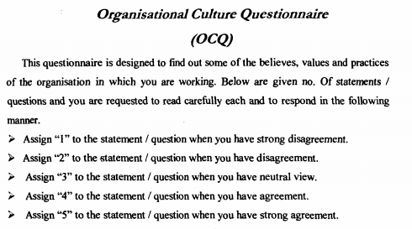

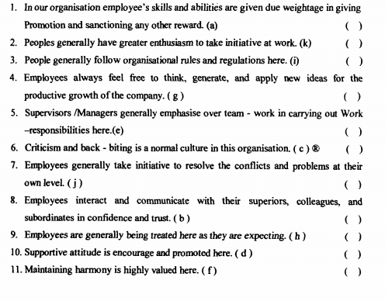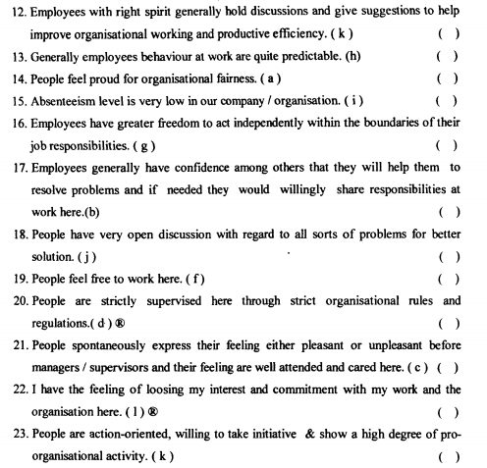

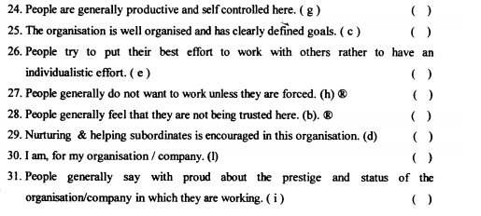

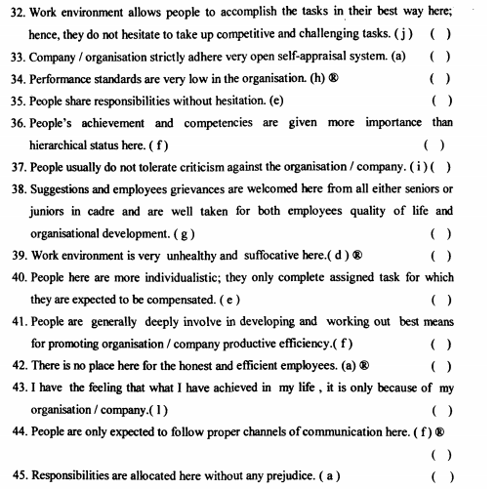

**QUESTIONNAIRE — II**

**JOB DESCRIPTIVE INDEX**

(All the information provided will be treated strictly confidential; your identity will not be disclosed at any stage)

Kindly give your opinion by (√) in the appropriate box below statement.

|  |  |  |  |
| --- | --- | --- | --- |
| **Scale Statement** | **Option** | | |
| **This organization is a pretty good place to work.** | **Y** | **N** | **?** |
| **The organization provides you with flexible working hours.** | **Y** | **N** | **?** |
| **The organization provides safe and sound working conditions to its employees.** | **Y** | **N** | **?** |
| **The wage rates of this organization are competitive with those of other institutions.** | **Y** | **N** | **?** |
| **If given an opportunity to earn more money, you leave this job for money.** | **Y** | **N** | **?** |
| **The organization provides you with adequate job benefits.** | **Y** | **N** | **?** |
| **The rewards in the organization are, equal for all of the employees.** | **Y** | **N** | **?** |
| **You are satisfied with the present promotion opportunities.** | **Y** | **N** | **?** |
| **The authority is fair in giving promotions.** | **Y** | **N** | **?** |
| **Your job is secure as compared to any other Govt. / Private job.** | **Y** | **N** | **?** |
| **This job is according to your qualification.** | **Y** | **N** | **?** |
| **This job is matching with your interests and skills.** | **Y** | **N** | **?** |
| **Your job is mentally challenging.** | **Y** | **N** | **?** |
| **You are given special assignments.** | **Y** | **N** | **?** |
| **You feel that you are not being used to your full capability.** | **Y** | **N** | **?** |
| **Your job is repetitive and boring.** | **Y** | **N** | **?** |
| **You are satisfied with the resources and opportunities provided by the organization to help you develop professionally.** | **Y** | **N** | **?** |
| **Your supervisor's behavior is supportive for you.** | **Y** | **N** | **?** |
| **You have good interaction with your coworkers.** | **Y** | **N** | **?** |
| **You have enough participation in decisions regarding your job.** | **Y** | **N** | **?** |
| **The organization willingly accepts the ideas of its members for change.** | **Y** | **N** | **?** |
| **The organization encourages employees to exercise their own initiatives.** | **Y** | **N** | **?** |
| **The management is always willing to listen and solve problems faced by the employees.** | **Y** | **N** | **?** |
| **The organizational rules and regulations hinder your performance.** | **Y** | **N** | **?** |
| **The organization takes active interest in the progress of its members.** | **Y** | **N** | **?** |
| **The organization recognizes that its life depends on its members.** | **Y** | **N** | **?** |
| **You are satisfied with your job.** | **Y** | **N** | **?** |